THIRD GRADE MATHEMATICS
UNIT 5 STANDARDS
Dear Parents,
As we shift to Common Core Standards, we want to make sure that you have an understanding of the mathematics your child will be learning this year. Below you will find the standards we will be learning in Unit Five. Each standard is in bold print and underlined and below it is an explanation with student examples. Your child is not learning math the way we did when we were in school, so hopefully this will assist you when you help your child at home. Please let your teacher know if you have any questions ☺

MCC.3.G.1 Understand that shapes in different categories (e.g., rhombuses, rectangles, and others) may share attributes (e.g., having four sides), and that the shared attributes can define a larger category (e.g., quadrilaterals). Recognize rhombuses, rectangles, and squares as examples of quadrilaterals, and draw examples of quadrilaterals that do not belong to any of these subcategories.
In second grade, students identify and draw triangles, quadrilaterals, pentagons, and hexagons. Third graders build on this experience and further investigate quadrilaterals. Students recognize shapes that are and are not quadrilaterals by examining the properties of the geometric figures. They conceptualize that a quadrilateral must be a closed figure with four straight sides and begin to notice characteristics of the angles and the relationship between opposite sides. Students should be encouraged to provide details and use proper vocabulary when describing the properties of quadrilaterals. They sort geometric figures (see examples below) and identify squares, rectangles, and rhombuses as quadrilaterals.
Students should classify shapes by attributes and drawing shapes that fit specific categories. For example, parallelograms include: squares, rectangles, rhombi, or other shapes that have two pairs of parallel sides. Also, the broad category quadrilaterals include all types of parallelograms, trapezoids and other four-sided figures.
Example:
Draw a picture of a quadrilateral. Draw a picture of a rhombus. How are they alike? How are they different? Is a quadrilateral a rhombus? Is a rhombus a quadrilateral? Justify your thinking.

MCC.3.G.2 Partition shapes into parts with equal areas. Express the area of each part as a unit fraction of the whole. For example, partition a shape into 4 parts with equal area, and describe the area of each part as 1/4 of the area of the shape.
This standard builds on students’ work with fractions and area. Students are responsible for partitioning shapes into halves, thirds, fourths, sixths and eighths.
Example:
This figure was partitioned/divided into four equal parts. Each part is ¼ of the total area of the figure.
Given a shape, students partition it into equal parts, recognizing that these parts all have the same area. They identify the fractional name of each part and are able to partition a shape into parts with equal areas in several different ways.

MCC.3.MD.3 Draw a scaled picture graph and a scaled bar graph to represent a data set with several categories. Solve one- and two-step “how many more” and “how many less” problems using information presented in scaled bar graphs. For example, draw a bar graph in which each square in the bar graph might represent 5 pets.
Students should have opportunities reading and solving problems using scaled graphs before being asked to draw one. The following graphs all use five as the scale interval, but students should experience different intervals to further develop their understanding of scale graphs and number facts. While exploring data concepts, students should Pose a question, Collect data, Analyze data, and Interpret data (PCAI). Students should be graphing data that is relevant to their lives
Example:
Pose a question: Student should come up with a question. What is the typical genre read in our class?

Collect and organize data: student survey
Pictographs: Scaled pictographs include symbols that represent multiple units. Below is an example of a pictograph with symbols that represent multiple units. Graphs should include a title, categories, category label, key, and data. How many more books did Juan read than Nancy?

Number of Books Read
Nancy | 
Juan
 | = 5 books

Single Bar Graphs: Students use both horizontal and vertical bar graphs. Bar graphs include a title, scale, scale label, categories, category label, and data.
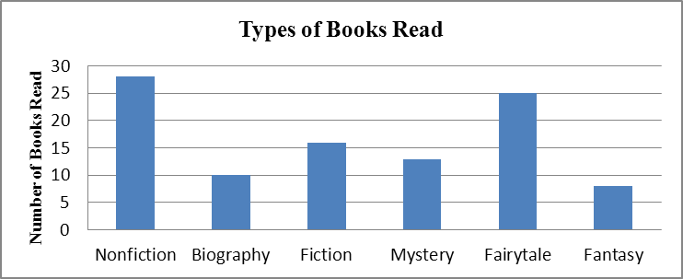

Analyze and Interpret data:
- How many more nonfiction books where read than fantasy books?
- Did more people read biography and mystery books or fiction and fantasy books?
- About how many books in all genres were read?
- Using the data from the graphs, what type of book was read more often than a mystery but less often than a fairytale?
- What interval was used for this scale?
- What can we say about types of books read? What is a typical type of book read?
- If you were to purchase a book for the class library which would be the best genre? Why?

MCC.3.MD.4 Generate measurement data by measuring lengths using rulers marked with halves and fourths of an inch. Show the data by making a line plot, where the horizontal scale is marked off in appropriate units – whole numbers, halves, or quarters.
Students in second grade measured length in whole units using both metric and U.S. customary systems. It is important to review with students how to read and use a standard ruler including details about halves and quarter marks on the ruler. Students should connect their understanding of fractions to measuring to one-half and one-quarter inch. Third graders need many opportunities measuring the length of various objects in their environment. This standard provides a context for students to work with fractions by measuring objects to a quarter of an inch. Example: Measure objects in your desk to the nearest ½ or ¼ of an inch, display data collected on a line plot. How many objects measured ¼? ½? etc. …

